**Experiment Title-3.1.2**

**Student Name: ADITYA RAJ** **UID:21BCS8948**

**Branch: CSE**  **Section/Group: ONBCS703/A**

**Semester: 3rd Date of Performance:12/11/2022**

**Subject Name: DBMS Subject Code:21 CSH-214**

**1. Aim/Overview of the practical:** Write a procedure and call it into main pl/sql program to find a factorial of a number.

**2. Source Code:**

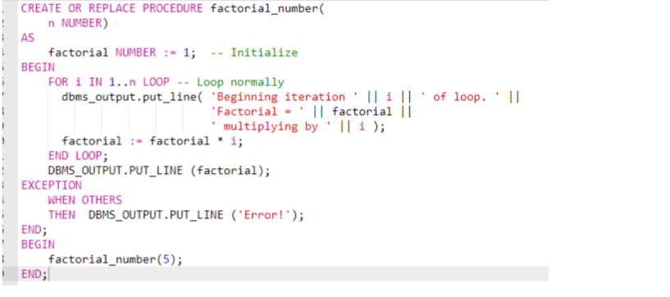

**3. Result/Output:**

